**What is staking and how can I make money from it?**

Staking involves keeping (locking) cryptocurrencies in a proof-of-stake blockchain for a period of time.

You can compare staking with interest on a savings account. You define your cryptocurrencies for a certain period of time - 1 month, 3 months or available daily and receive so-called "rewards (rewars are similar to interest)". For the time in which you determine your cryptocurrencies, you cannot dispose of them. However, some exchanges such as Binance, for example, offer if you need your money during the term that you can then dispose of it, but do not receive any rewards.

Staking is a good way to build passive income.

**How does staking work?**

You have your cryptocurrencies on a crypto exchange (for example Binance, Coinbase, Crypto.com). Before that, you check which cryptocurrencies the respective exchange allows staking for. This varies depending on the stock exchange. The percentages of the rewards also vary. On exchange 1 you may get 2%, on exchange 2 10% and on exchange 3 you cannot stake the cryptocurrency at all.

You can then specify this for the selected time and you will then be paid the rewards.

Example

1000 - 10% APY = 100 per year Rewards

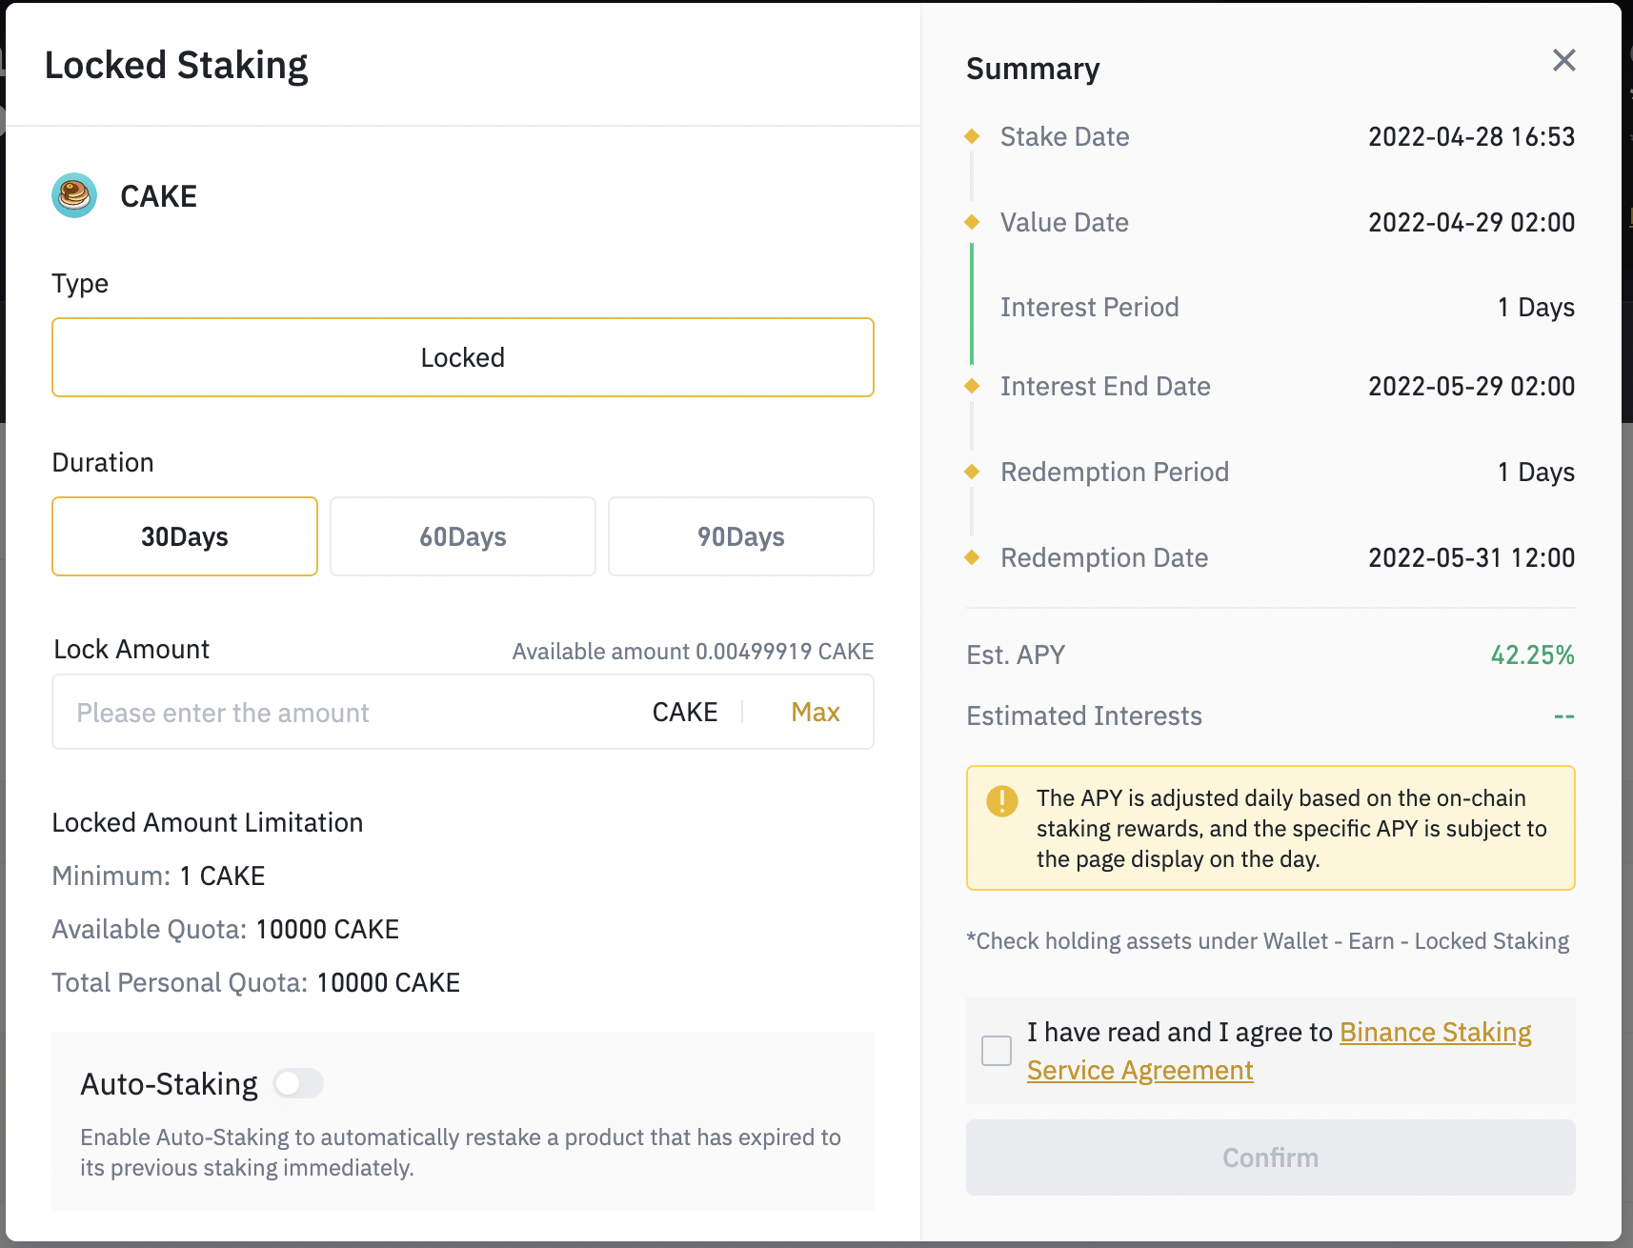

Why can I make money with this?

The “proof of stake” procedure is used for staking. With each stake you help the respective blockchain to validate and verify the transactions in the system

The advantage is that with staking you support the security and efficiency of the respective blockchain. By committing some of your funds to staking, you make the blockchain more resilient to hacking while supporting the ability to transact.